AI ASSISTED CODING
NAME: P HARSHAVARDHAN
ROLL.NO:2503A52366
Task 1 – Classes: Data Validation
Prompt:
Create a Python Student class with attributes name, roll_no, and marks. Add an is_pass() method that returns True if marks are ≥ 40, otherwise False. Include a constructor, sample input, and output.
CODE:
class Student:
def __init__(self, name, roll_no, marks):
# Data validation
if not isinstance(name, str) or name.strip() == "":
raise ValueError("Name must be a non-empty string")

if not isinstance(roll_no, int) or roll_no <= 0:
raise ValueError("Roll number must be a positive integer")

if not isinstance(marks, (int, float)) or marks < 0 or marks > 100:
raise ValueError("Marks must be between 0 and 100")

self.name = name
self.roll_no = roll_no
self.marks = marks

def is_pass(self):
return self.marks >= 40

# Creating student objects
student1 = Student("Rahul", 101, 75)
student2 = Student("Priya", 102, 35)

# Checking pass/fail status
print(student1.name, ":", student1.is_pass())
print(student2.name, ":", student2.is_pass())
OUTPUT:
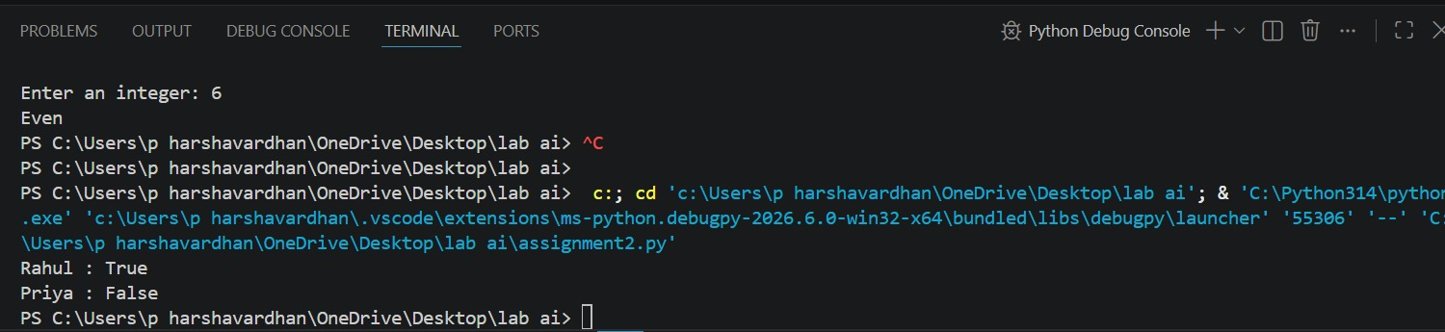

Task 2 – Loops: Pattern Generation
Prompt:
Write Python functions to print a right-angled triangle star pattern using both a for loop and a while loop. Use 5 rows and show the output.
CODE:
def triangle_for(n):
for i in range(1, n + 1):
print("* " * i)

# Function call
triangle_for(5)
Output:
*
* *
* * *
* * * *
* * * * *
OUTPUT:
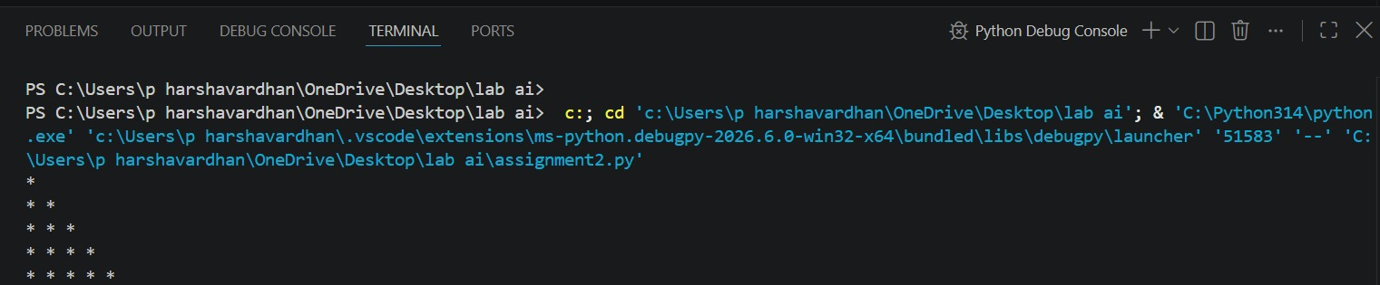

Task 3 – Conditional Statements: Number Analysis
Prompt:
Write a Python function using if-elif-else to check whether a given number is positive, negative, or zero. Test it with multiple numbers and show the output.
CODE:
def check_number(num):
if num > 0:
return "Positive"
elif num < 0:
return "Negative"
else:
return "Zero"

# Testing with multiple inputs
print(check_number(10))
print(check_number(-5))
print(check_number(0))
print(check_number(25))
print(check_number(-12))
OUTPUT:
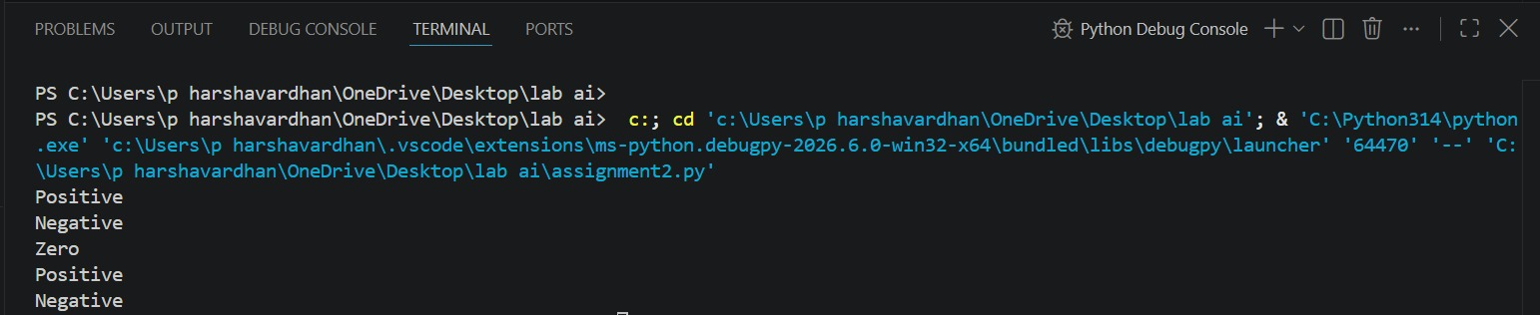

Task 4 – Nested Conditionals
Prompt:
Write a Python function check_discount(age, is_member) using nested if statements. Give a senior discount for age ≥ 60 and an additional discount for members. Explain the decision flow and show sample outputs.
CODE:
def check_discount(age, is_member):
if age >= 60:
if is_member:
return "Senior discount + Additional member discount"
else:
return "Senior discount"
else:
if is_member:
return "Additional member discount"
else:
return "No discount"

# Testing with multiple inputs
print(check_discount(65, True))
print(check_discount(65, False))
print(check_discount(30, True))
print(check_discount(30, False))
OUTPUT:
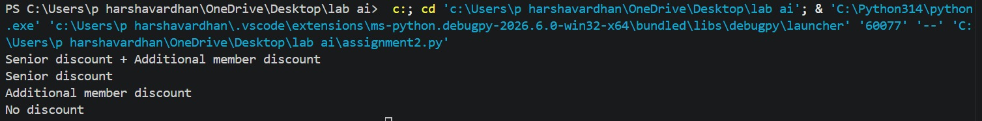

Task 5 – Classes: Mathematical Operation
Prompt:
Create a Python Circle class with a radius attribute and methods area() and circumference(). Use π = 3.14, include sample input/output, and briefly explain the code.
CODE:
import math

class Circle:
def __init__(self, radius):
self.radius = radius

def area(self):
return math.pi * self.radius ** 2

def circumference(self):
return 2 * math.pi * self.radius

# Creating a Circle object
circle = Circle(5)

print("Radius:", circle.radius)
print("Area:", circle.area())
print("Circumference:", circle.circumference())
OUTPUT:
